Sensory Organs (Nervous System)
“WEB QUEST”
Name __________________________________



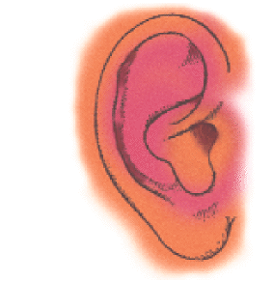
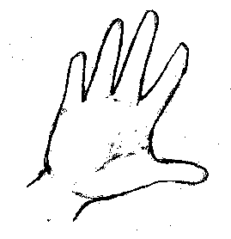

In animals, sense receptors provide information about what is taking place both inside and outside the body. The receptors of the human nervous system range from those in the skin, which are relatively simple structures, to the eye and ear, which are very complex organs.
Goal:
- Increase your understanding of the 5 senses by working through several web sites devoted to the topic.

1. Go to http://www.enchantedlearning.com/subjects/anatomy/ear/

2. Use the Internet page to label the following in the figure below:

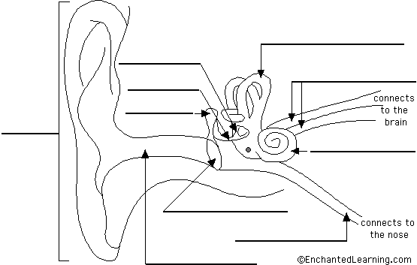

3. Go to http://www.kidshealth.org/kid/body/ear_SW.html

◦ Describe the main functions of the ear.

◦ What is the outer ear called, what is function how does its form facilitate this function?

◦ What is the function of ear wax?

◦ What is the function of the inner ear?

◦ What does the ear drum separate ?

◦What are ear ossicles? What are there names?

◦Explain how the Cochlea converts sounds into a signal that the brain can process.

◦Read Day or Night, Ears Keep You Upright and explain how the ear helps one to maintain his or her balance.

4. Go to http://www.enchantedlearning.com/subjects/anatomy/skin/index.shtml

Use the Internet page to label the following in the figure below:

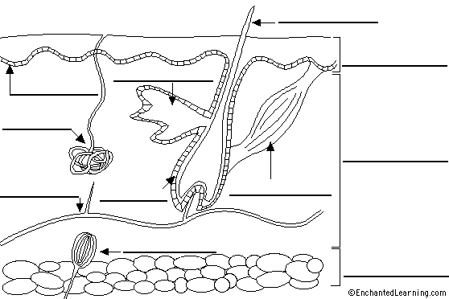

5. Go to http://faculty.washington.edu/chudler/nosek.html

◦ What is olfaction?

◦ What are hair cells? Where are they located?

◦ List the path olfactory (stimuli) information starting at the olfactory bulb.

◦ What is anosmia?

◦How many odors can a human distinguish?

6. Go to http://legacy.owensboro.kctcs.edu/gcaplan/anat/notes/api%20notes%20n%20senses-smell.htm and label the diagrams.
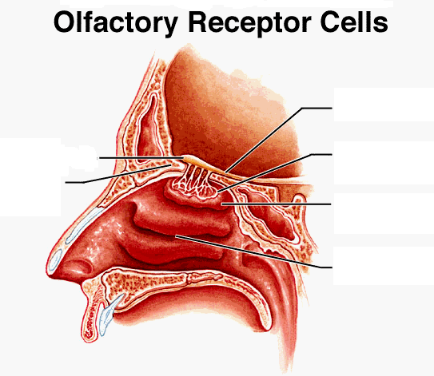
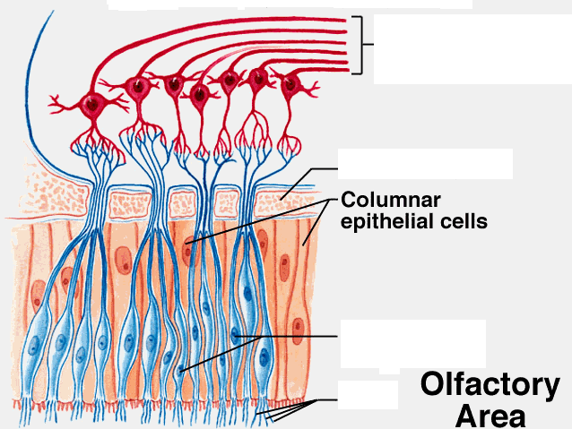

7. Go to http://health.howstuffworks.com/eye1.htm and label the diagram. Then read the description of each labeled part.
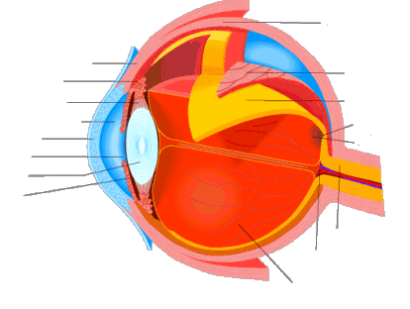

8. Click on the Perceiving Light.

◦What structures in the eye does light pass through before hitting the retina?

◦What are the functions of rods and cones?

◦How many rods and cones does the retina contain?

◦What does the pigment melanin do?

◦What chemical creates a chemical impulse in the optic nerves?

◦What part of the brain do nerves go to so the brain can process the light stimuli?

9. Go to http://www.cf.ac.uk/biosi/staff/jacob/teaching/sensory/taste.html and label the right side of the diagram. Then answer the questions that follow.

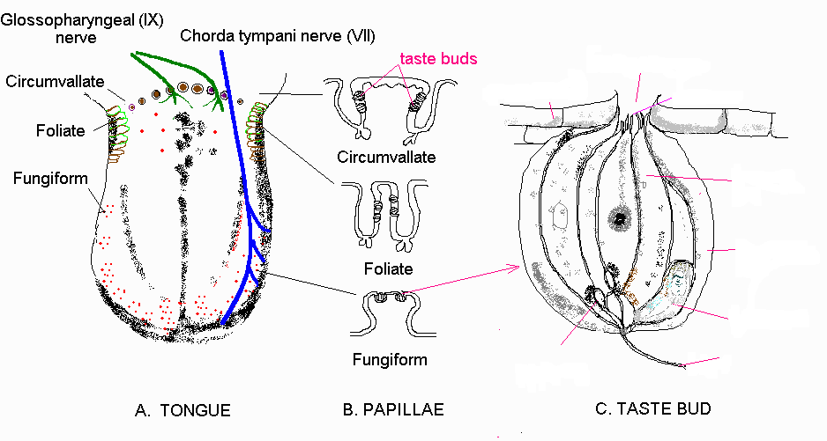

10. Scroll to Cells in taste papillae and define the following.
What is significance or importance of tasting food or anything else that might be ingested?

11. Scroll to Cells in taste papillae and define the following.

- Supporting cells

- Sensory receptor cell

- Basal cells

12. Scroll to taste transduction and describe the five types of taste.

